Project ID: 25-26J-144
Project Title: An Intelligent System for Detection, Translation, and Historical Mapping of Ancient Inscriptions

1. Introduction

1.1. Background:

The Anuradhapura period represents one of the most important eras in Sri Lankan history. Thousands of stone inscriptions from this period record royal grants, religious donations, administrative orders, and social customs. These inscriptions are invaluable for understanding the political, cultural, and religious development of ancient Sri Lanka and serve as primary sources for reconstructing the island’s early civilization.

However, most inscriptions are severely degraded due to natural weathering, biological growth, pollution, vandalism, and poor documentation practices. Manual reading requires trained epigraphists and is extremely time-consuming, and many inscriptions remain partially unreadable or completely undocumented. This situation not only slows historical research but also increases the risk of permanent loss of cultural knowledge as stones continue to erode over time.

This research project proposes an intelligent system to digitally preserve and analyze ancient inscriptions using automated image enhancement, character recognition, translation, knowledge extraction, and restoration. The system is organized into four main components: Image Sharpening and Character Segmentation, Character Recognition, Translation and Knowledge Extraction, Multimodal Restoration, and Contextual Completion. Together, these components form a complete pipeline that transforms degraded stone inscriptions into clear, readable, and searchable digital records, enabling faster research, reducing human error, and ensuring that Sri Lanka’s ancient heritage can be preserved and shared with future generations.

1.2. Research Problem:

Ancient stone inscriptions from the Anuradhapura period contain critical historical, cultural, and religious information about early Sri Lankan civilization. However, many of these inscriptions are in poor physical condition due to centuries of weathering, erosion, biological growth, and human damage. As a result, many inscriptions are blurred, cracked, partially missing, or difficult to read even by experts.

Current documentation methods rely heavily on manual inspection and transcription by trained epigraphists. This process is slow, expensive, and limited by human availability and expertise. In addition, manual methods are prone to inconsistency and subjective interpretation, and they do not scale well for thousands of inscriptions scattered across archaeological sites.

There is no integrated automated system that can enhance degraded inscription images, accurately recognize ancient characters, translate the text, extract historical knowledge, and restore missing parts in a single pipeline. The absence of such a system limits large-scale digitization, preservation, and analysis of ancient inscriptions from Anuradhapura, making it difficult to protect this heritage and make it accessible for research, education, and public use.

1.3. Objectives:

IT Number | Objective | Objective number
IT22586070 | To enhance degraded inscription images using sharpening, contrast adjustment, and noise removal techniques, and to accurately segment each inscription into individual character regions for further analysis. | 1
IT22089304 | To identify and classify ancient characters from segmented images using machine learning and deep learning models, ensuring reliable conversion from visual symbols to digital text. | 2
IT22069436 | To translate recognized ancient text into modern Sinhala and English, and to automatically extract important historical information such as names, places, dates, and events. | 3
IT22108890 | To restore missing or damaged parts of inscriptions by combining visual restoration techniques with language-based contextual prediction, ensuring historically consistent and readable outputs. | 4

2. Data Exploration

2.1. Data Collection

- Field Photography and Manual Annotation: Inscription images were collected from archaeological sites, temples, museums, and historical locations in the Anuradhapura district. These images were manually reviewed and annotated with information such as visible characters, damage level, and readability to create structured datasets for analysis.

- Digitized Archaeological Records: Images and transcriptions were obtained from archaeological books, research publications, museum archives, and heritage websites. These resources provided verified references for training character recognition and translation models.

- Primary Textual Source – Inscriptions of Ceylon:
Inscriptions of Ceylon – Volume I by Senerath Paranavithana was used as a key reference. Brahmi inscriptions and their scholarly interpretations from this book were manually digitized and translated to create the core translation dataset.

- Synthetic Data Generation: Artificial inscription images were created using ancient-style fonts and then degraded with noise, blur, cracks, and stone textures using image processing techniques. This synthetic data supports early-stage testing and model training when real data is limited.

- Expert Collaboration: Data and expert guidance were obtained through collaboration with Prof. Raj Somadeva and master’s students in archaeology and history. Their expertise supported accurate annotation, validation of transcriptions, translations, and historical interpretations, improving the reliability and academic value of the dataset.

2.2. Dataset Description:

No. | Data source | Description | Resource | Size | Key Attributes
1 | Raw Inscription Images | Real photographs of stone inscriptions from Anuradhapura, mainly based on Inscriptions of Ceylon - Volume I (First Wanuma) and field photos | Inscriptions of Ceylon - Volume I (First Wanuma) | 200+ images | Lighting, erosion, surface type
2 | Synthetic Inscription Images | Generated inscription-style text based on characters from Inscriptions of Ceylon - Volume I, with added noise and blur | OpenCV | 499 images | Noise level, blur level, font
3 | Brahmi Inscription Text | Digitized Brahmi inscription sentences manually typed from ancient stone inscriptions | Inscriptions of Ceylon – Volume I by Senerath Paranavithana | 1,234 inscriptions | Script variations, lack of word boundaries, orthographic forms
4 | Sinhala Translation Text | Manually created Sinhala translations corresponding to Brahmi inscriptions | Manually translated from English explanations in Inscriptions of Ceylon – Volume I | 1,234 sentences | Cultural meaning, historical terminology
5 | Word-Pair Translation Dataset | Brahmi–Sinhala word pairs extracted from inscription translations for normalization and mapping | Derived from inscription translation dataset | Unique word pairs | Lexical variants, canonical mappings
6 | Brahmi letters dataset | Contains more than 1000 imagers per letter | Keggle | Brahmi letter images | Character label, image
7 | Damaged inscriptions dataset | Contains more than 6000 Inscription Images | Generated from Inscription images | Damaged inscription Images | Damaged image, Restored Image

2.3. Suitability Analysis

2.3.1. Relevance to Individual Research Objectives:

The datasets align perfectly with the research as it contains domain-specific, high-quality data directly related to financial services, products, and organizations in both Sinhala and English.

 | 1 | 2 | 3 | 4
Data source 1 | x
Data source 2 | x
Data source 3 |  |  | x
Data source 4 |  |  | x
Data source 5 |  |  | x
Data source 6 |  | x
Data source 7 |  |  |  | x

3. Methodology

3.1. Data Preprocessing:

Objective 1 : IT22586070
 | Data Cleaning | Data Normalization | Data Encoding | Feature Engineering | Manual  Correction | Data Mapping | Manual Correction
Data source 1 | x | x | x | x | x | x | Manually refined segmentation results and corrected bounding boxes to ensure accurate character separation
Data source 2 | x | x | x | x | x | x | Manually adjusted noise levels, blur intensity, and verified segmentation outputs for realistic simulation

Objective 2 : IT22089304

 |  |  | Transformation technique
 | Data Cleaning | Data Normalization | Data Encoding | Feature Engineering | Manual  Correction | Data Mapping
Data source 6 | Removed corrupted images, background noise, blurred and mis-segmented characters | Resized all character images to 128×128 pixels and normalized pixel intensities to [0,1] | Class labels were encoded using folder-based class indexing (one class per Brahmi letter) | Deep CNN (ResNet18) automatically extracted stroke shapes, curves, edges and texture features | Mislabelled and unclear characters were manually verified and corrected | Each character image was mapped to its corresponding Brahmi symbol class

Objective 3: IT22069436
 | Data Cleaning | Data Normalization | Data Encoding | Feature Engineering | Manual  Correction | Data Mapping | Manual Correction
Data source 3 | x | x | x | x | x | x | Manually typed Brahmi inscription text was cleaned, normalized, encoded, and aligned with corresponding Sinhala translations. Manual corrections were applied to handle script variations and sentence-level alignment.
Data source 4 | x | x | x | x | x | x | Sinhala translations were manually refined, Unicode-normalized, and corrected to preserve historical and cultural meaning before being used for translation and knowledge extraction.
Data source 5 | x | x | x | x | x | x | Brahmi–Sinhala word pairs were extracted from inscription translations, normalized, manually validated, and mapped to canonical forms to support translation consistency and knowledge extraction.

Objective 4 : IT22108890

 |  |  | Transformation technique
 | Data Cleaning | Data Normalization | Data Encoding | Feature Engineering | Manual  Correction | Data Mapping
Data source 7 | x | x | x | x | x | Each Damaged image has mapped to Restored image

3.2. Scalability

- Data Source 1:
Inscription images collected from Inscriptions of Ceylon provide high-quality, well-documented examples of ancient inscriptions from the Anuradhapura period. Although the dataset size is limited, it is sufficient for this component because image sharpening and character segmentation rely on image processing techniques rather than heavy model training. The data includes different carving styles and damage levels, making it suitable for testing and development.

- Data Source 2:
Synthetic images are generated because of limited access to real inscriptions and time constraints for progress presentations. They are created using ancient-style fonts and then degraded with noise, blur, and cracks to simulate real inscription conditions for early testing and demonstration.

- Data Source 3:
The Brahmi inscription text dataset was created by manually digitizing inscriptions from Inscriptions of Ceylon - Volume I by Senerath Paranavithana. Although the dataset contains 1,234 inscriptions, which is moderate in size, it is sufficient for this component because the focus is on translation and knowledge extraction rather than large-scale language modeling. The dataset includes script variations, lack of word boundaries, and orthographic differences, making it suitable for evaluating the scalability of translation models. The system design allows additional inscriptions from other volumes or regions to be easily incorporated in future work.
- Data Source 4:
The Sinhala translation dataset consists of 1,234 manually created sentences, translated from English explanations provided in Inscriptions of Ceylon – Volume I. While the dataset size is limited by the availability of verified inscriptions, it is adequate for fine-tuning translation models and conducting comparative experiments. The modular design of the translation pipeline enables seamless expansion by adding more translated inscriptions, allowing the system to scale with future data availability.

- Data Source 5:
The word-pair translation dataset was derived from the inscription translation dataset by extracting unique Brahmi–Sinhala word mappings. This dataset is inherently scalable, as new word pairs can be automatically or semi-automatically added when additional inscriptions are processed. The use of canonical mappings allows consistent normalization across the dataset, supporting scalable translation and knowledge extraction as the corpus grows.
- Data Source 6:
This dataset consists of segmented Brahmi character images used for training the character recognition model. Each class represents one Brahmi letter, and approximately 1,000 images were collected per character. The images were obtained from segmented inscription samples and synthetic character generation, ensuring a wide variety of writing styles, noise levels, and erosion patterns. The dataset includes variations in stroke thickness, shape distortion, background texture, and illumination, which reflect real-world inscription conditions. This diversity makes the dataset suitable for training a deep learning model to accurately recognize ancient Brahmi characters from degraded stone inscriptions.
- Data Source 7:
The restoration dataset consists of paired damaged and clean Brahmi character images created for training the character restoration model. Clean character images were generated from segmented inscription characters, and realistic damage such as noise, blur, cracks, and erosion was added using Python-based image processing techniques to simulate stone deterioration. In addition to synthetic samples, real damaged inscription character images were also included to ensure the model learns authentic degradation patterns. This combination provides a diverse and realistic dataset for training the character restoration network.

3.3. Feature extraction

Objective 1: IT22586070
1.Key Features Evaluated:
- Edges and contours of carved characters extracted from inscription images.
- Connected components representing individual character regions.
- Bounding box features such as x-position, y-position, width, height, and area.
- Pixel intensity patterns of segmented characters.
- Noise and background artifacts affecting character clarity.

2.Feature Transformation:
- Inscription images were converted to grayscale and then to binary format.
- Noise was removed using morphological operations.
- Connected component analysis transformed pixel regions into character-level features.
- Bounding box coordinates were used to crop and normalize character images.
- Segmented characters were resized and prepared for use in recognition models.

Objective 2: IT22089304

- Key Features Evaluated
For Brahmi character recognition, the model learned and analyzed several important visual features from the segmented character images:
- Stroke shapes and curves of Brahmi letters
- Thickness and orientation of carved strokes
- Endpoints, intersections, and junctions of strokes
- Structural patterns unique to each character
- Texture variations caused by stone carving and erosion
These features are essential for distinguishing visually similar Brahmi characters that differ only by small stroke variations.
- Feature Transformation
Before learning features, each character image was transformed as follows:
- Converted to grayscale to remove irrelevant color information
- Resized to a fixed resolution (128 × 128 pixels)
- Pixel values normalized to improve learning stability
- Data augmentation applied to simulate erosion, distortion, and noise
After preprocessing, a deep convolutional neural network (ResNet-18) automatically extracted hierarchical features from the images. Early layers captured basic edges and curves, while deeper layers learned complex Brahmi character structures. These learned features were then used to classify each character into its correct Brahmi class.

Objective 3: IT22069436

1. Key Features Evaluated
- Tokenized Brahmi text features, including character and subword patterns
- Normalized Sinhala word forms derived from inscription translations
- Lexical features from the word-pair translation dataset (Brahmi–Sinhala mappings)
- Frequency of key inscription terms such as monasteries, donations, and royal titles
- Contextual relationships between words used for knowledge extraction
- Structural patterns commonly found in Brahmi inscriptions (donor–donation formats)

2. Feature Transformation
- Brahmi and Sinhala texts were Unicode-normalized to ensure consistency
- Text was cleaned and tokenized using subword tokenization suitable for Transformer models
- Word boundaries were refined using known inscription vocabulary
- Sentence-level features were transformed into input–output token sequences for translation
- Extracted entities were converted into structured representations for knowledge extraction
- Word-pair mappings were transformed into canonical forms to support normalization and consistency

Objective 4: IT22108890
- Key Features Evaluated
The restoration model learned the following features from damaged Brahmi characters:
- Stroke continuity and shape
- Missing or broken stroke patterns
- Edge and boundary information of characters
- Texture differences between stone noise and real strokes
- Spatial structure of each character
These features allowed the model to distinguish between actual character strokes and damage artifacts.
- Feature Transformation
Each damaged image was passed through a convolutional encoder that extracted multi-scale visual features. These were processed through skip connections in a U-Net architecture to preserve fine stroke details while learning high-level character structure. The decoder then reconstructed a clean version of the character by combining texture and shape information.

4. Modelling and Results

4.1. Key Insights:
Objective 1: IT22586070
- Image sharpening significantly improves the visibility of carved strokes, making characters clearer for segmentation.
- Morphological noise removal helps eliminate small cracks and stains without damaging main character shapes.
- Connected component analysis works well when characters are clearly separated.
- Segmentation accuracy decreases when characters touch or erosion connects strokes.
- Padding around crops improves the quality of segmented characters for later recognition.
- Visual previews with bounding boxes are essential for manual verification and correction.
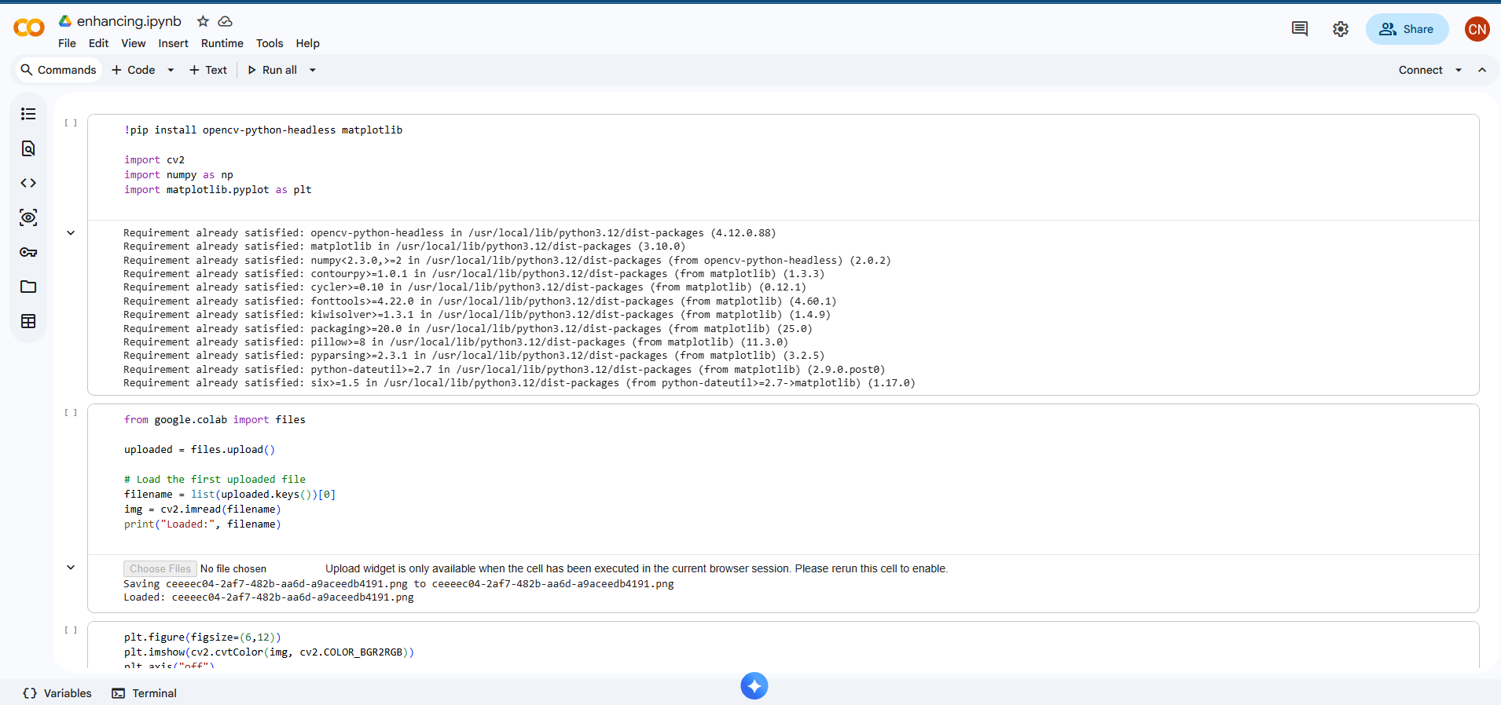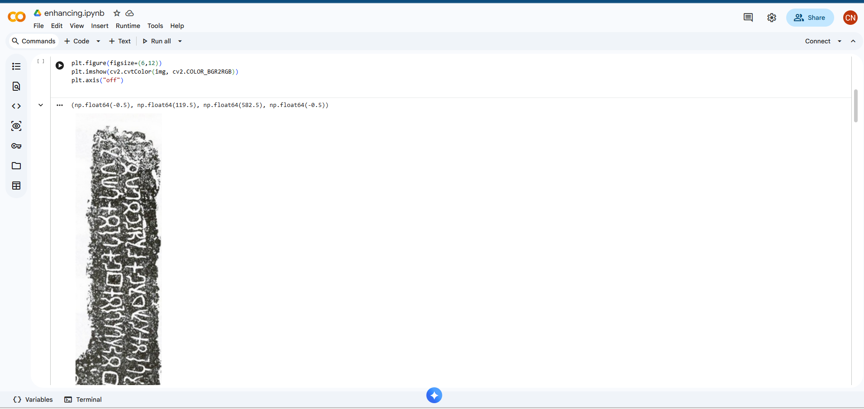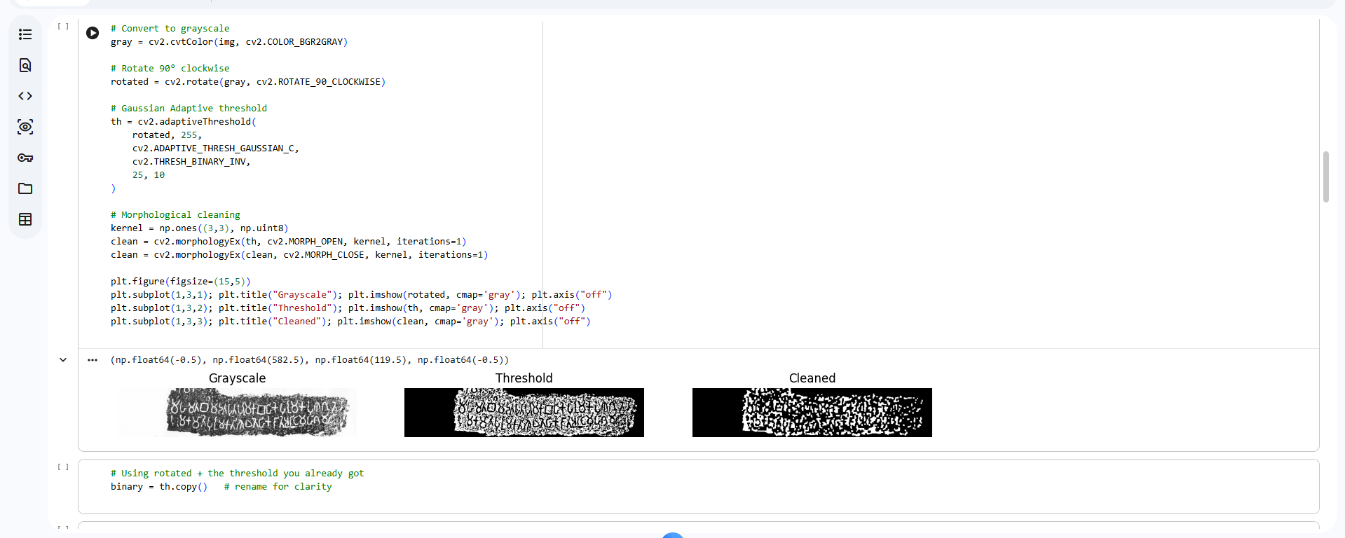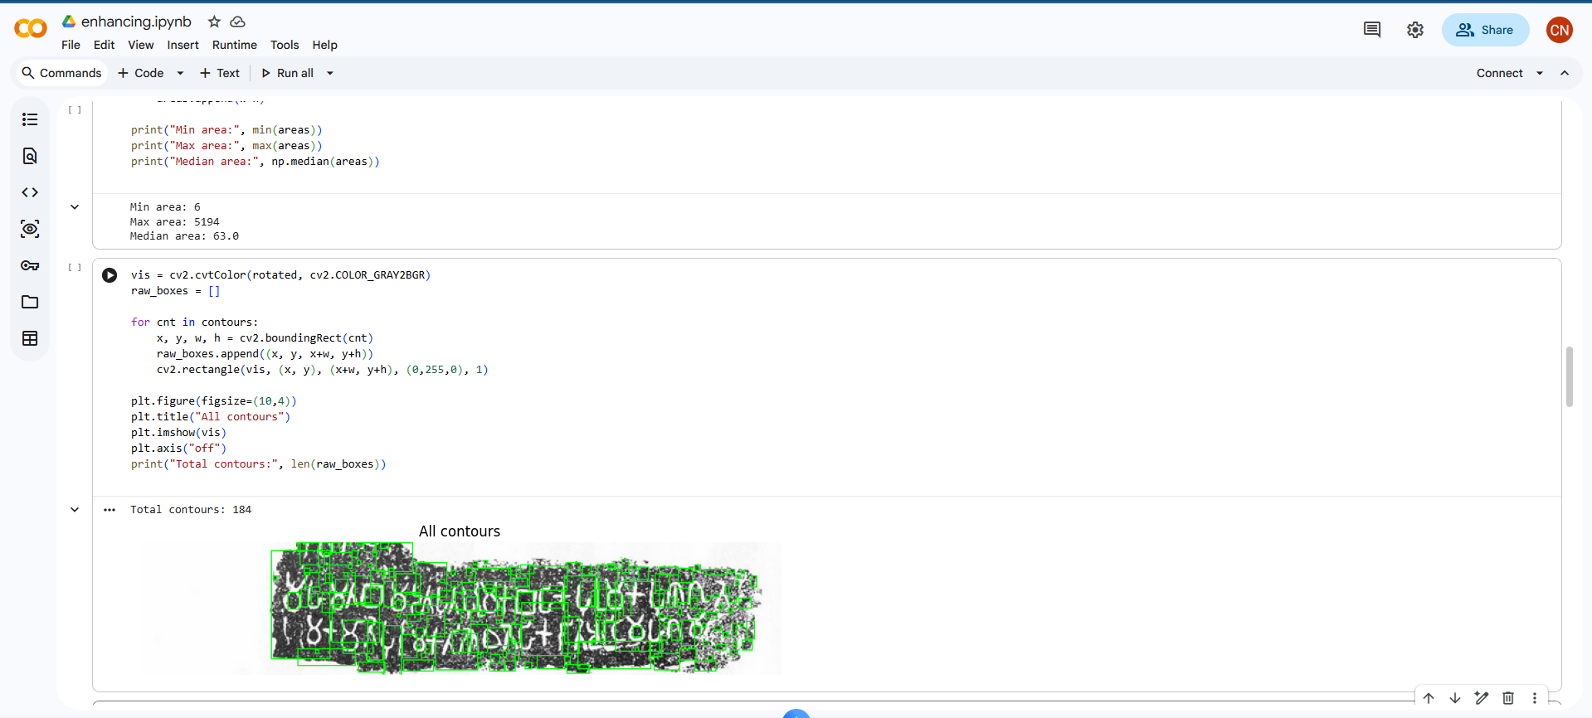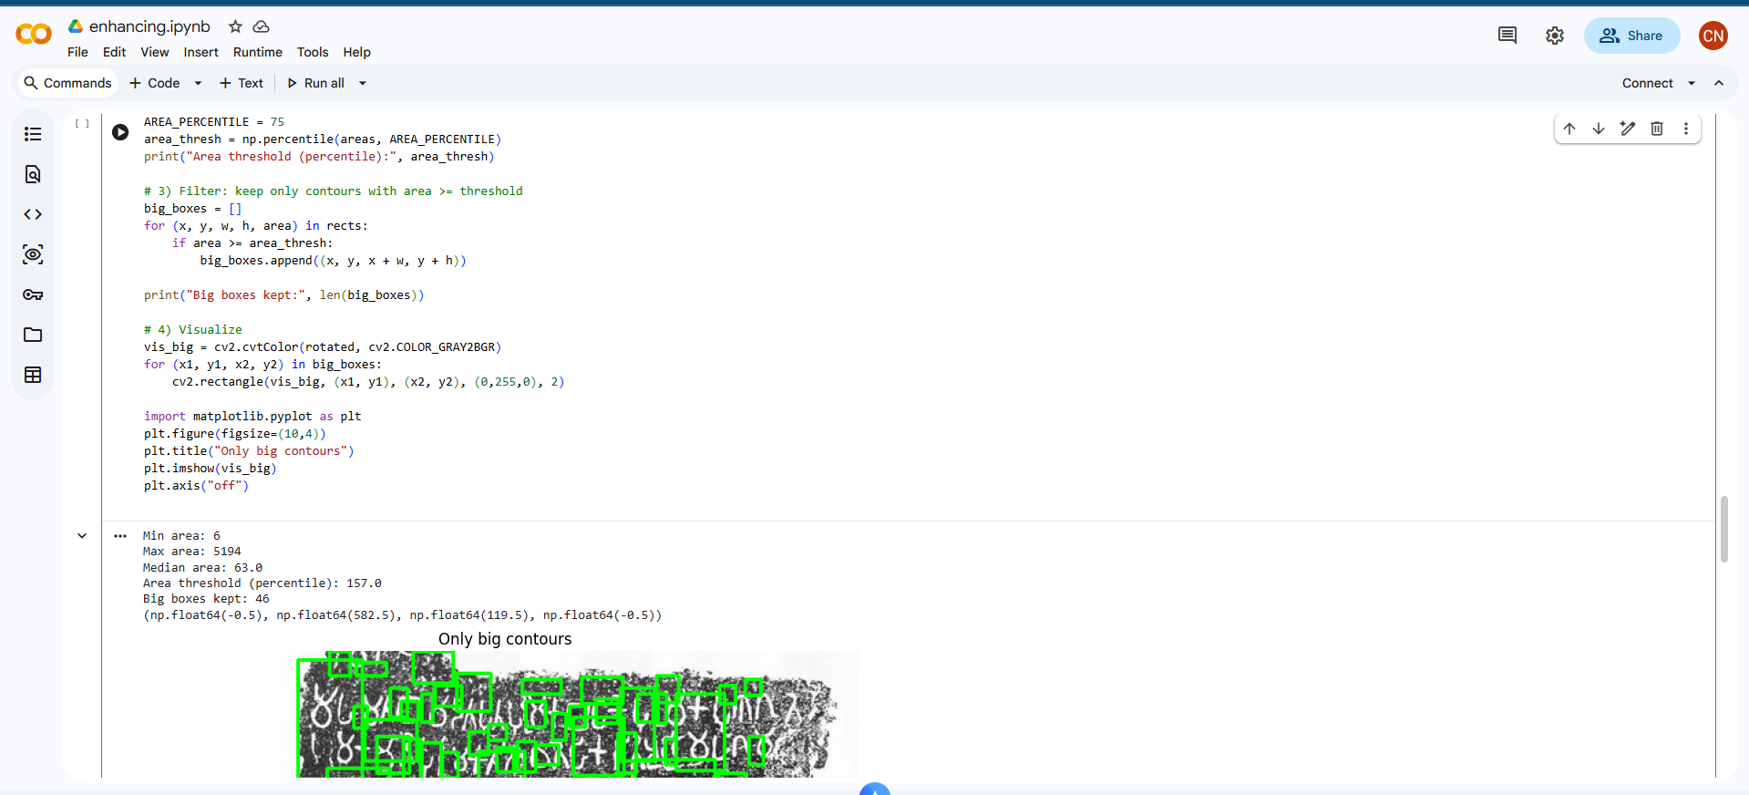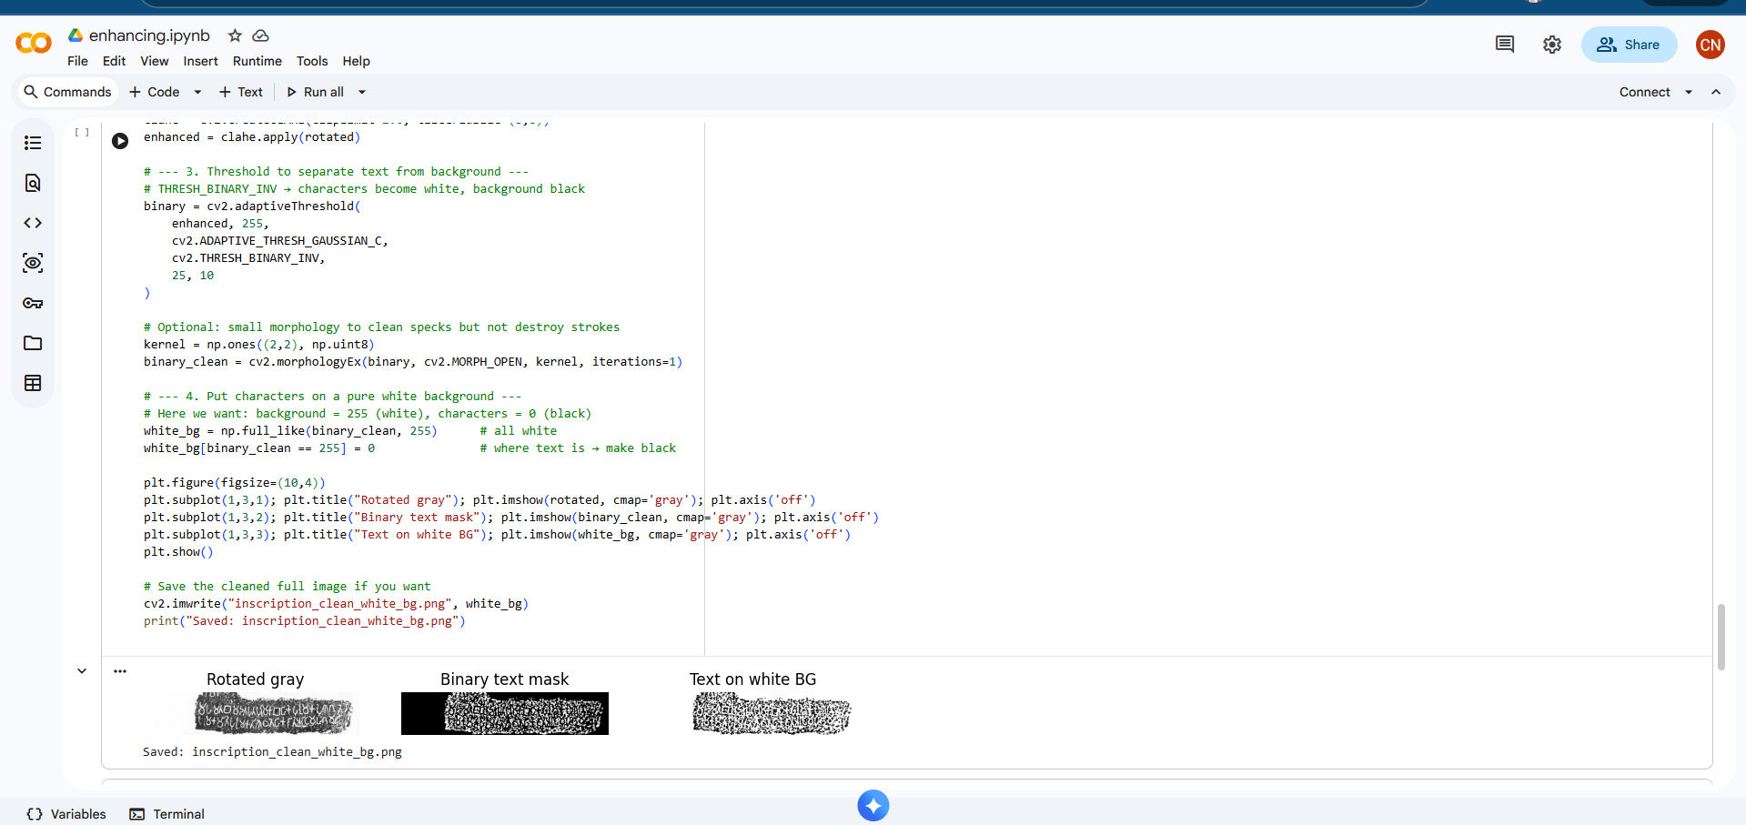

Objective 2: IT22089304

Model Design
The Brahmi character recognition task was implemented using a deep convolutional neural network based on the ResNet-18 architecture. ResNet-18 was selected due to its strong performance in image classification and its ability to learn deep hierarchical features while avoiding vanishing gradient problems through residual connections.
The model was initialized with ImageNet pretrained weights and fine-tuned for Brahmi character classification. The final fully connected layer was replaced with a new layer containing 23 output nodes, corresponding to the Brahmi character classes in the dataset.

Training Strategy
The dataset containing 1000 images per Brahmi character was split using a stratified approach into:
- 80% for training
- 10% for validation
- 10% for testing
Training was performed for 20 epochs using a batch size of 64. The AdamW optimizer was used with cross-entropy loss, as it provides stable convergence and regularization through weight decay. A learning-rate scheduler was applied to reduce the learning rate when validation accuracy stopped improving, helping to prevent overfitting.
During training, data augmentation such as rotation, scaling, translation, contrast variation, and blur was applied to improve the model’s robustness to noise, erosion, and distortions commonly found in stone inscriptions.

Results
The trained model achieved strong performance in recognizing Brahmi characters from segmented inscription images. The use of data augmentation and transfer learning significantly improved generalization to unseen samples.
The system successfully learned to distinguish visually similar characters based on stroke patterns, structural layout, and texture information. The best model was selected automatically based on validation accuracy and was then evaluated on the test dataset to measure final performance.
Overall, the character recognition component reliably converts segmented Brahmi character images into digital character labels, enabling accurate downstream translation and restoration of ancient inscriptions.

Objective 3: IT22069436
- Transformer-based fine-tuning using mT5 successfully learned the mapping from ancient/inscription Sinhala to modern Sinhala.
- Using Sinhala as an intermediate language helped preserve cultural and historical meaning during translation.
- Data cleaning and normalization significantly improved model stability and reduced noise in training.
- Validation loss decreased steadily and stabilized, indicating good generalization without severe overfitting.
- The achieved BLEU score (≈30) indicates strong translation quality for a low-resource, historical dataset.
- The ChrF score (≈62) shows good character-level alignment, which is important for Sinhala morphology.
- Manual dataset creation contributed directly to improved translation accuracy and consistency.
- Word-pair translation mappings improved normalization and supported downstream knowledge extraction.
- Extracted entities such as monasteries, donations, and royal references were more accurate when applied to translated text rather than raw inscriptions.

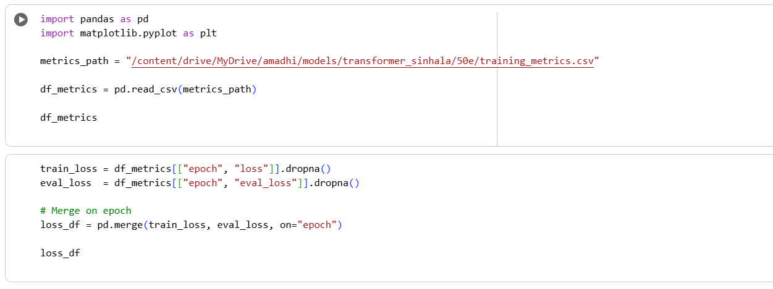

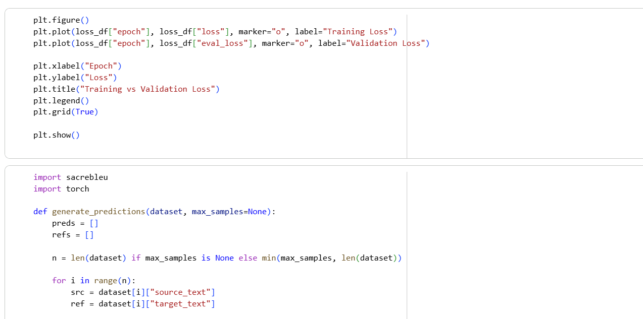

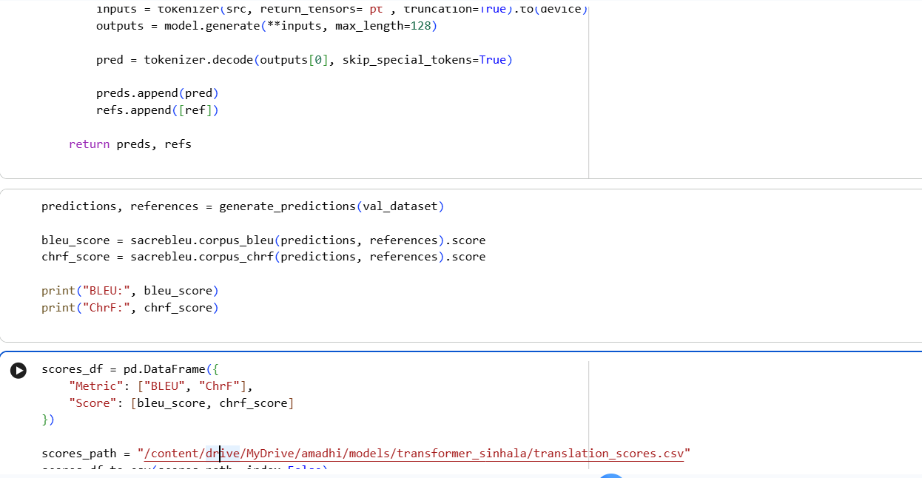Objective 4: IT22108890

Model Design
An enhanced U-Net based deep convolutional neural network (Improved U-Net) was used to restore damaged Brahmi characters. The model uses an encoder–decoder architecture with skip connections to preserve fine-grained stroke information while learning global character structure.

Loss Function
A Composite Loss Function was used, combining:
- L1 Loss – to preserve pixel-level accuracy
- SSIM Loss – to maintain structural similarity between restored and clean characters
- Edge Loss (Sobel) – to enhance stroke sharpness and boundary clarity
This combination allows the model to generate visually accurate and sharp restorations instead of blurry outputs.

Training Strategy
The dataset was divided into training and validation sets (90% / 10%). The model was trained for up to 30 epochs using the Adam optimizer with learning-rate scheduling and early stopping.
Mixed precision training was applied to improve training speed and memory efficiency. The model that achieved the lowest validation loss was automatically saved as the best model.

Results
The trained restoration model produced clearer, sharper, and more complete Brahmi characters from damaged inputs. Quantitative metrics such as PSNR (Peak Signal-to-Noise Ratio) and SSIM (Structural Similarity Index) were used to evaluate restoration quality.
The results showed that the model was able to:
- Recover missing strokes
- Remove noise and cracks
- Preserve the original shape and structure of characters
This significantly improved the readability of damaged inscriptions and provided cleaner inputs for character recognition and translation.
4.2. Challenges Faced During Data Analysis

Objective 1: IT22586070
The analysis of inscription images presented several challenges, mainly during the data collection and preprocessing stages. The key challenges are described below.
Data Gathering Challenges:
- Limited Access to Real Inscriptions:
Collecting real inscription images from archaeological sites is difficult due to permission requirements, site restrictions, and limited availability of documented images. Many high-quality images are not publicly accessible.
- Quality of Available Images:
Images from books and archives such as Inscriptions of Ceylon are sometimes low in resolution, scanned, or contain background noise from printing and aging, which affects image processing accuracy.
- Field Photography Issues:
When taking photos, lighting conditions, shadows, camera shake, and surface reflections reduce image quality and consistency.
Data Preprocessing Challenges:
- Noise and Damage:
Inscriptions contain cracks, stains, moss, and erosion that look similar to characters, making it difficult to separate noise from real text.
- Threshold Selection:
Choosing a single threshold value that works for all images is difficult because brightness and contrast vary widely.
- Touching and Broken Characters:
Some characters are connected due to carving style or erosion, while others are partially missing, making segmentation inaccurate.
Manual Effort:
- Manual Correction:
Automatic segmentation is not always perfect. Bounding boxes and segmented characters often need manual checking and correction.
- Expert Dependency:
Identifying correct character shapes requires guidance from historical references and experts.
Computational Limits:
- Batch Processing Time:
Processing large numbers of high-resolution images increases time and memory usage.
- Hardware Constraints:
Running image processing on limited hardware sometimes caused slow performance.
Overall, these challenges required repeated testing, parameter tuning, and manual validation to achieve acceptable segmentation results for ancient inscription images.

Objective 2: IT22089304
The analysis of Brahmi character images for recognition presented several challenges, mainly during dataset preparation, preprocessing, and model training. The key challenges are described below.

Data Gathering Challenges
Limited Availability of Labeled Data:
Real Brahmi character images from inscriptions are limited and difficult to obtain. Many characters appear only a few times in real inscriptions, making it hard to build a balanced dataset without relying on synthetic samples.
Class Imbalance Risk:
Some Brahmi characters appear more frequently than others in historical inscriptions. Without careful dataset construction, this can bias the model toward commonly occurring characters.

Data Preprocessing Challenges
Noise and Degradation:
Segmented characters often contain stone texture, cracks, erosion, and background noise, which interfere with the visibility of character strokes and reduce recognition accuracy.
Shape Variations:
The same Brahmi character can appear in different carving styles, stroke thicknesses, and distortions due to erosion and writing variation, making consistent classification difficult.
Incomplete Characters:
Some segmented characters are partially broken or missing strokes, which leads to ambiguity and misclassification.

Model Training Challenges
Visual Similarity Between Characters:
Many Brahmi characters have very similar shapes and differ only by small stroke changes, making it difficult for the neural network to distinguish them reliably.
Overfitting Risk:
Because the dataset is limited compared to modern handwriting datasets, the model can memorize training samples instead of learning general patterns, especially without strong data augmentation.

Manual Effort
Label Verification:
Some segmented images were incorrectly labeled due to segmentation errors or unclear strokes. These had to be manually inspected and corrected to improve training quality.
Data Cleaning:
Blurry, mis-segmented, or severely damaged characters were manually removed to prevent the model from learning incorrect patterns.

Computational Limits
Training Time:
Training a deep convolutional neural network with thousands of images and data augmentation increased training time, especially on limited GPU or CPU resources.
Memory Usage:
High-resolution images and batch processing placed significant demands on memory, requiring careful batch-size selection and optimization.
Overall, these challenges required careful data cleaning, augmentation, and model tuning to achieve reliable Brahmi character recognition from degraded inscription images.

Objective 3: IT22069436
The analysis of Brahmi inscriptions presented several challenges, mainly during data collection, preprocessing, and model training stages. The key challenges are described below.
Data Gathering Challenges
- Lack of Existing Datasets:
There are no publicly available Brahmi–Sinhala parallel datasets suitable for machine learning. Most existing resources provide inscriptions with explanations rather than structured translation pairs.
- Manual Dataset Creation:
All Brahmi inscriptions and Sinhala translations had to be manually typed and aligned using Inscriptions of Ceylon – Volume I. This process was time-consuming and required careful attention to accuracy.
- Interpretation Complexity:
The meanings in the source book are often explained in English sentences, not direct Sinhala translations. Converting these explanations into culturally accurate Sinhala translations require interpretation rather than direct translation.

Data Preprocessing Challenges

- Lack of Word Boundaries:
Brahmi and ancient Sinhala inscriptions do not contain clear word separations, making tokenization and normalization difficult.
- Orthographic Variations:
The same word appears in multiple spelling forms across inscriptions, requiring normalization and word-pair mapping to maintain consistency.
- Noise in Textual Data:
Unwanted symbols, formatting artifacts, and inconsistent Unicode representations had to be carefully cleaned to avoid affecting model training.

Model Training Challenges

- Limited Dataset Size:
Although 1,234 inscriptions were prepared, the dataset is relatively small for deep learning models, increasing the risk of overfitting.
- Hyperparameter Selection:
Choosing suitable values for learning rate, batch size, and number of epochs required repeated experimentation to achieve stable training.
- Validation Fluctuations:
Due to dataset size, validation loss showed minor fluctuations, requiring careful monitoring to select the best-performing model.

Manual Effort and Validation

- Manual Correction and Verification:
Translations, word-pair mappings, and extracted entities required manual validation to ensure historical and cultural correctness.
- Expert Dependency:
Guidance from archaeological literature and expert knowledge was necessary to validate translations and extracted knowledge.

Computational Constraints

- Training Time:
Fine-tuning Transformer models required significant training time, especially when running multiple experiments.
- Hardware Limitations:
Limited GPU availability constrained batch size and experimentation speed during model training.

The analysis of damaged Brahmi character restoration presented several challenges, mainly during data preparation, model training, and visual quality evaluation. The key challenges are described below.

Objective 4: IT22108890
Data Gathering Challenges
Lack of Real Paired Data:
There are no publicly available datasets that provide paired damaged and clean versions of Brahmi characters. Real inscriptions usually contain only damaged characters, making it difficult to obtain ground-truth clean images for supervised learning.
Synthetic Data Generation:
To overcome the lack of paired data, clean Brahmi characters had to be artificially degraded using noise, blur, cracks, and erosion. Designing degradation patterns that realistically represent stone damage required careful tuning.

Data Preprocessing Challenges
Variation in Damage Patterns:
Different inscriptions contain varying levels of cracks, erosion, and surface noise. Ensuring that synthetic damage matches real-world conditions was challenging.
Preserving Stroke Structure:
While applying degradation, it was important not to destroy the original stroke structure of characters, as excessive noise would make restoration unrealistic.

Model Training Challenges
Reconstruction Complexity:
Restoring missing or broken strokes requires the model to infer missing parts based on learned character structure, which is more difficult than simple denoising.
Balancing Sharpness and Smoothness:
Pixel-based losses can cause blurry outputs, while edge-based losses may introduce artifacts. Balancing these objectives required careful tuning of the composite loss function.
Training Stability:
Training deep U-Net models with SSIM and edge losses required careful learning-rate scheduling and early stopping to prevent instability and overfitting.

Manual Effort and Validation
Visual Evaluation:
Restored outputs had to be visually inspected to verify whether recovered strokes were historically and visually plausible.
Sample Selection:
Validation samples were manually reviewed to ensure that the restored characters maintained correct Brahmi shape and structure before being passed to recognition and translation modules.

5. References
[1] Archaeological Survey of Ceylon. Inscriptions of Ceylon – Volume I (First Wanuma). Department of Archaeology, Sri Lanka.
[2] S. Paranavitana, Inscriptions of Ceylon – Early Brahmi and Ancient Sinhala Inscriptions. Department of Archaeology, Sri Lanka.
[3] Bradski, G., & Kaehler, A. (2008). Learning OpenCV: Computer Vision with the OpenCV Library. O’Reilly Media.
[4] OpenCV Developers. OpenCV Documentation.
https://docs.opencv.org
[5] Gonzalez, R. C., & Woods, R. E. (2018). Digital Image Processing. Pearson Education.
[6] Goodfellow, I., Bengio, Y., & Courville, A. (2016). Deep Learning. MIT Press.

